Assignment 9 - Savitha Balarajan

1. Create AFTER UPDATE trigger to track product price changes

· Create product_price_audit table with below columns:
audit_id SERIAL PRIMARY KEY,
product_id INT,
product_name VARCHAR(40),
old_price DECIMAL(10,2),
new_price DECIMAL(10,2),
change_date TIMESTAMP DEFAULT CURRENT_TIMESTAMP,
user_name VARCHAR(50) DEFAULT CURRENT_USER

· Create a trigger function with the below logic:

INSERT INTO product_price_audit (
product_id,
product_name,
old_price,
new_price
)
VALUES (
OLD.product_id,
OLD.product_name,
OLD.unit_price,
NEW.unit_price
);
· Create a row level trigger for below event:
AFTER UPDATE OF unit_price ON products

· Test the trigger by updating the product price by 10% to any one product_id.
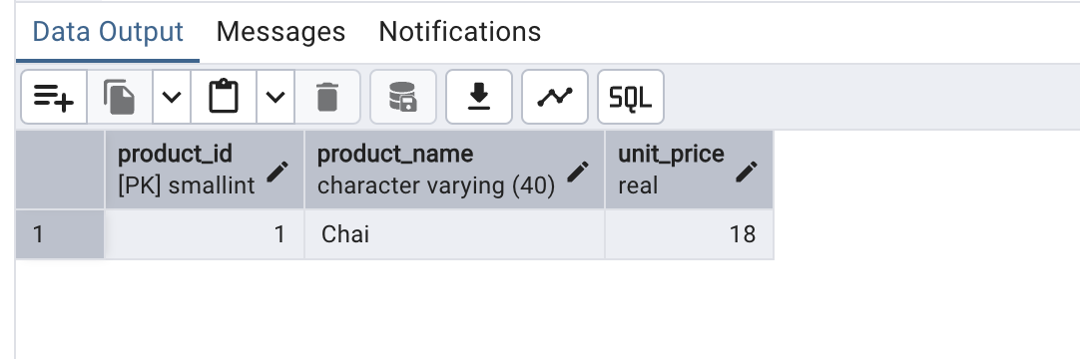
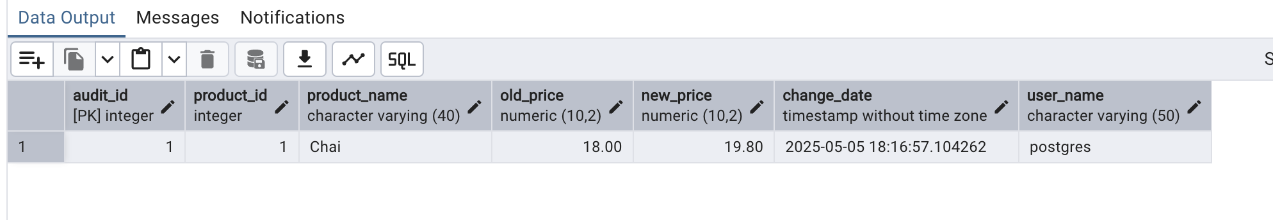

2. Create stored procedure using IN and INOUT parameters to assign tasks to employees

· Parameters:
IN p_employee_id INT,
IN p_task_name VARCHAR(50),
INOUT p_task_count INT DEFAULT 0

· Inside Logic: Create table employee_tasks:
CREATE TABLE IF NOT EXISTS employee_tasks (
task_id SERIAL PRIMARY KEY,
employee_id INT,
task_name VARCHAR(50),
assigned_date DATE DEFAULT CURRENT_DATE
);

· Insert employee_id, task_name into employee_tasks
· Count total tasks for employee and put the total count into p_task_count .
· Raise NOTICE message:
RAISE NOTICE 'Task "%" assigned to employee %. Total tasks: %',
p_task_name, p_employee_id, p_task_count;

After creating stored procedure test by calling it:
CALL assign_task(1, 'Review Reports');

You should see the entry in employee_tasks table.

